Name ____________________

Explain how materials move in and out of a cell.

<https://www.youtube.com/watch?v=kfy92hdaAH0>

# Active and Passive Transport

[](https://www.youtube.com/user/JCCCvideo)[JCCCvideo](https://www.youtube.com/channel/UCfyN7moqhBJbILGTjPVv42g)

Period____Date____________

CELL TRANSPORT

**Match the definition on the left with the term on the right.**

1. _____ release of wastes or cell products from inside to outside a cell
2. diffusion
3. dynamic equilibrium
4. exocytosis
5. osmosis
6. _____ diffusion of water molecules through a selectively permeable

membrane

1. _____ continuous movement of particles but no overall change in

concentration

1. _____ movement of particles from an area of higher concentration to one

of lower concentration

**In the space at the left, write true if the statement is true. If the statement is false, change the italicized term to make the statement true. Write this answer in the blank provided.**

_______________ 5. In *passive transport*, the movement of particles across a membrane requires energy.

_______________ 6. *Endocytosis* is a process by which a cell membrane surrounds and takes in material from

the environment.

_______________ 7. A membrane that allows only some materials to pass through shows *selective permeability.*

**Circle the word or phrase that best completes the statement or answers the question.**

8. The structure most responsible for maintaining cell ***homeostasis*** is the

**cytoplasm cell wall mitochondria cell membrane**

9. A cell membrane is made up of a(n)

**cholesterol layer enzyme layer lipid bilayer protein layer**

10. Which of the following is not a form of passive transport?

**diffusion endocytosis osmosis**

11. Diffusion continues until

**equilibrium is reached turgor pressure is reached one side has more**

12. If a fresh water plant cell is placed in salt water, water leaves the cell by

**osmosis diffusion active transport phagocytosis**

13. A cell moves particles from a region of lesser concentration to a region of higher concentration by

**diffusion osmosis passive transport active transport**

**Use the pictures on the left to answer the questions on the right.**

**14. After digestion:**

 = glucose molecule

a. Which side has the higher concentration of glucose? ________

b. Which way will the glucose go? ________________________

**blood**

**cell**

c. Does this require energy? ___________

d. Is this active or passive transport? _______________________

**15. Easter egg coloring**:

A blue food coloring tablet is placed in a cup of vinegar and water. The blue tablet will

dissolve and spread evenly throughout the liquid.

beaker

a. Is this diffusion or osmosis? _______________________

b. Does this require energy? _________________________

c. Is the blue dye going from a lower to a higher concentration,

Water and vinegar

or from a higher to a lower concentration? ______________

Blue food color tablet

**16. Plant cell after being over-watered.**

1. 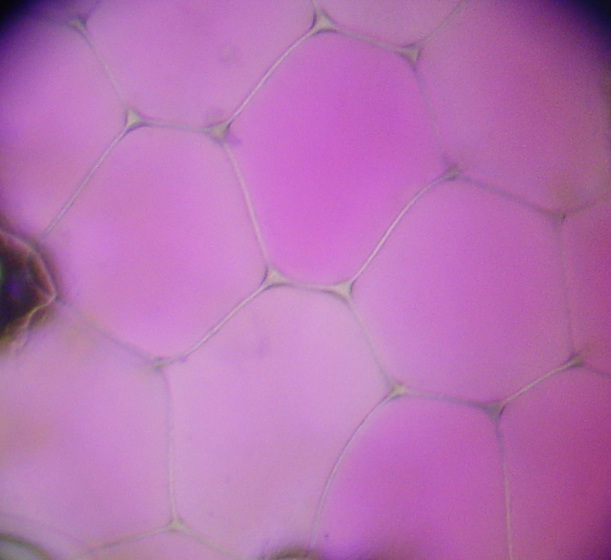Water rushes into the plant cell’s vacuole. Is this diffusion

or osmosis? _________________________

**17. Plant cell after not being watered lately, so it has begun to wilt:**

[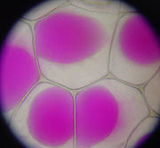](http://en.wikipedia.org/wiki/Image:Rhoeo_Discolor_-_Plasmolysis.jp)

1. Which way will the water go? Into the vacuole, or out of the

vacuole? ______________________

1. By what process will the water move?

____________________________

**18. An amoeba engulfs a particle of food.**

[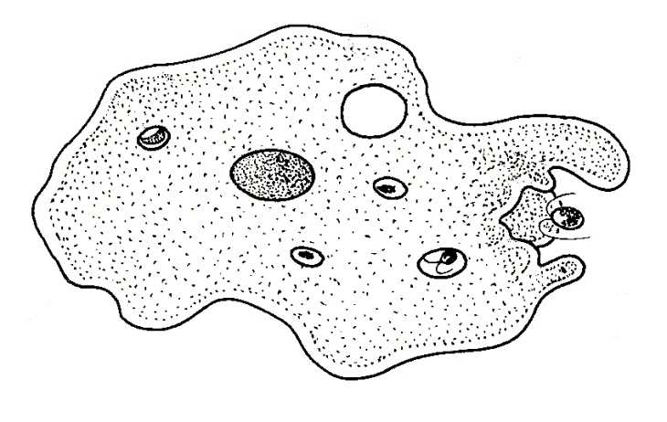](http://www.biology-resources.com/drawing-amoeba-breathing.htm)

1. Does this require energy?_______________________
2. Is this active or passive transport? _________________
3. Is this endocytosis or exocytosis? _________________

**19. An amoeba expels waste.**

1. [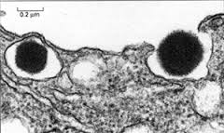](http://www.pitt.edu/~biohome/Dept/Img/graphics/diabetes2.jp)Does this require energy? ____________________
2. Is this active or passive transport? ______________
3. Is this endocytosis or exocytosis? __________________

Identify each image as: **diffusion**, **osmosis**, **passive transport, active transport**,

**exocytosis** or **endocytosis**.

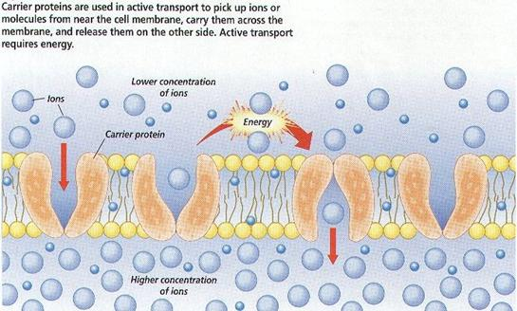

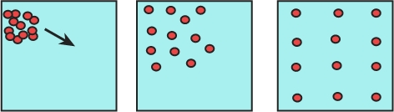

20. ________________________ 21. ________________________

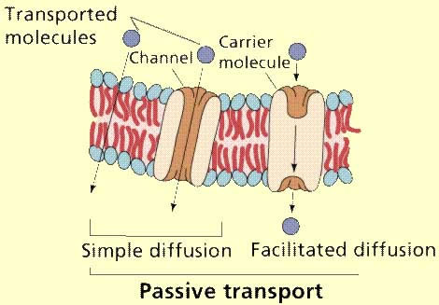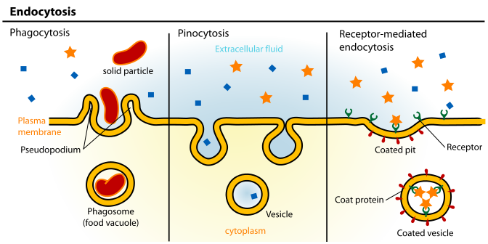

22. _________________________ 23. _____________________

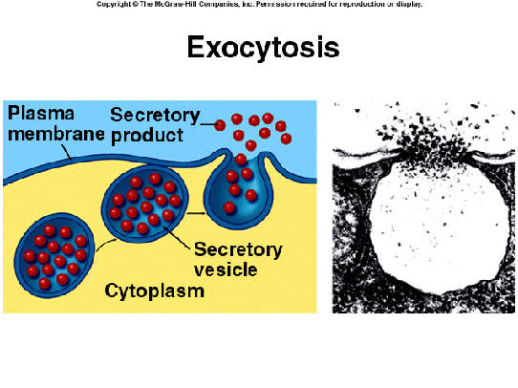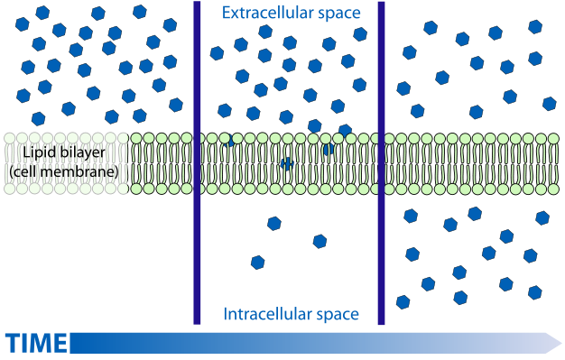

24. ______________________ 25. ____________________

26. Describe ***diffusion***:

* Moves things into/out of the cell (circle one or both!)
* Moves from high-to-low/low-to-high concentration(circle one)
* For large/small molecules (circle one or both!)
* Uses/does not use protein doorway (circle one)

27. Describe ***osmosis***:

* Moves things into/out of the cell (circle one or both!)
* Moves from high-to-low/low-to-high concentration (circle one)
* For large/small molecules (circle one or both!)
* Uses/does not use protein doorway (circle one)

28. Describe ***passive transport:***

* Moves things into/out of the cell (circle one or both!)
* Moves from high-to-low/low-to-high concentration (circle one)
* For large/small molecules (circle one or both!)
* Uses/does not use protein doorway (circle one)

29. Describe ***active transport***:

* Moves things into/out of the cell (circle one or both!)
* Moves from high-to-low/low-to-high concentration (circle one)
* For large/small molecules (circle one or both!)
* Uses/does not use protein doorway (circle one)

30. Describe ***endocytosis***:

* Example of active/passive (circle one)
* Moves things into/out of the cell (circle one or both!)
* For very large/small molecules (circle one or both!)

31. Describe ***exocytosis***:

* Example of active/passive (circle one)
* Moves things into/out of the cell (circle one or both!)
* For very large/small molecules (circle one or both!)

**Active and passive transport** are biological processes that move [oxygen](http://www.diffen.com/difference/Oxygen_vs_Ozone), water and nutrients into cells and remove waste products. Active transport requires chemical energy because it is the movement of biochemicals from areas of lower concentration to areas of higher concentration. On the other hand, passive transport moves biochemicals from areas of high concentration to areas of low concentration; so it does not require energy.

## Comparison chart

| Active Transport versus Passive Transport comparison chart | | |
| --- | --- | --- |
|  | **Active Transport** | **Passive Transport** |
| **Definition** | Active Transport uses ATP to pump molecules AGAINST/UP the concentration gradient. Transport occurs from a low concentration of solute to high concentration of solute. Requires cellular energy. | Movement of molecules DOWN the concentration gradient. It goes from high to low concentration, in order to maintain equilibrium in the cells. Does not require cellular energy. |
| **Types of Transport** | Endocytosis, cell membrane/sodium-potassium pump & exocytosis | Diffusion, facilitated diffusion, and osmosis. |
| **Functions** | Transports molecules through the cell membrane against the concentration gradient so more of the substance is inside the cell (i.e. a nutrient) or outside the cell (i.e. a waste) than normal. Disrupts equilibrium established by diffusion. | Maintains dynamic equilibrium of water, gases, nutrients, wastes, etc. between cells and extracellular fluid; allows for small nutrients and gases to enter/exit. No NET diffusion/osmosis after equilibrium is established. |
| **Types of Particles Transported** | proteins, ions, large cells, complex sugars. | Anything soluble (meaning able to dissolve) in lipids, small monosaccharides, water, oxygen, carbon dioxide, sex hormones, etc. |
| **Examples** | phagocytosis, pinocytosis, sodium/potassium pump, secretion of a substance into the bloodstream (process is opposite of phagocytosis & pinocytosis) | diffusion, osmosis, and facilitated diffusion. |
| **Importance** | In [eukaryotic cells](http://www.diffen.com/difference/Eukaryotic_Cell_vs_Prokaryotic_Cell), amino acids, sugars and lipids need to enter the cell by protein pumps, which require active transport.These items either cannot diffuse or diffuse too slowly for survival. | It maintains equilibrium in the cell. Wastes (carbon dioxide, water, etc.) diffuse out and are excreted; nutrients and oxygen diffuse in to be used by the cell. |

## Process

There are two types of active transport: primary and secondary. In primary active transport, specialized trans-membrane proteins recognize the presence of a substance that needs to be transported and serve as pumps, powered by the chemical energy ATP, to carry the desired biochemicals across. In secondary active transport, pore-forming proteins form channels in the cell membrane and force the biochemicals across using an electromagnetic gradient. Often, this energy is gained by simultaneously moving another substance down the concentration gradient.

[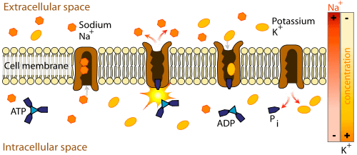](http://www.diffen.com/difference/Image:Active-Transport.png)

*[magnify](http://www.diffen.com/difference/Image:Active-Transport.png)*

*Example of primary****active transport****, where energy from hydrolysis of ATP is directly coupled to the movement of a specific substance across a membrane independent of any other species.*

There are four main types of passive transport: [osmosis, diffusion](http://www.diffen.com/difference/Diffusion_vs_Osmosis), facilitated diffusion and filtration. Diffusion is the simple movement of particles through a permeable membrane down a concentration gradient (from a more concentrated solution to a less concentrated solution) until the two solutions are of equal concentration. Facilitated diffusion uses special transport proteins to achieve the same [effect](http://www.diffen.com/difference/Affect_vs_Effect). Filtration is the movement of water and solute molecules down the concentration gradient, e.g. in the kidneys, and osmosis is the diffusion of water molecules across a selectively permeable membrane. None of these processes require energy.

[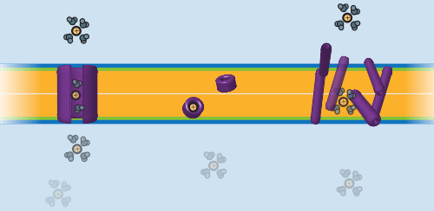](http://www.diffen.com/difference/Image:Passive-Transport.png)

*[magnify](http://www.diffen.com/difference/Image:Passive-Transport.png)*

*Three different mechanisms for****passive transport****in bilayer membranes. Left: ion channel (through a defined trajectory); center: ionophore/carrier (the transporter physical diffuses through with the ion); right: detergent (non-specific membrane disruption).*

## Examples

Examples of active transport include a sodium pump, glucose selection in the intestines, and the uptake of mineral ions by plant roots.

Passive transport occurs in the kidneys and the liver, and in the alveoli of the lungs when they exchange oxygen and carbon dioxide.